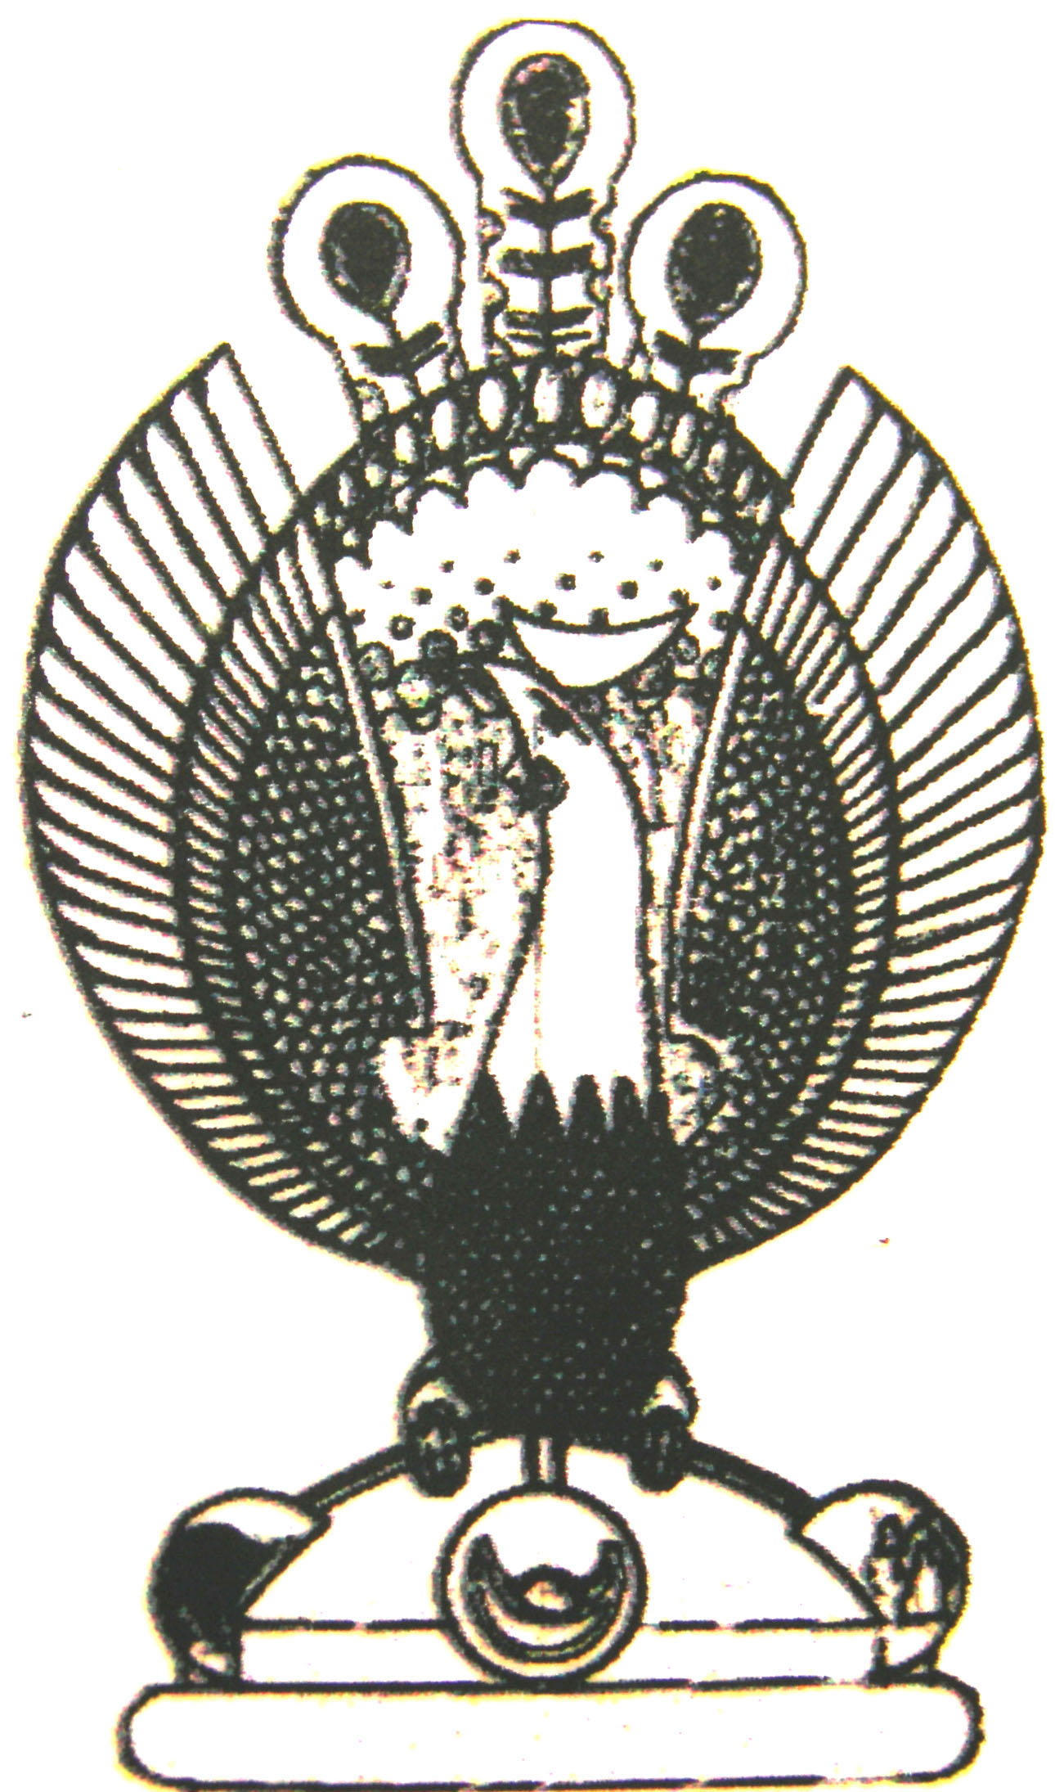

THE HERITAGE

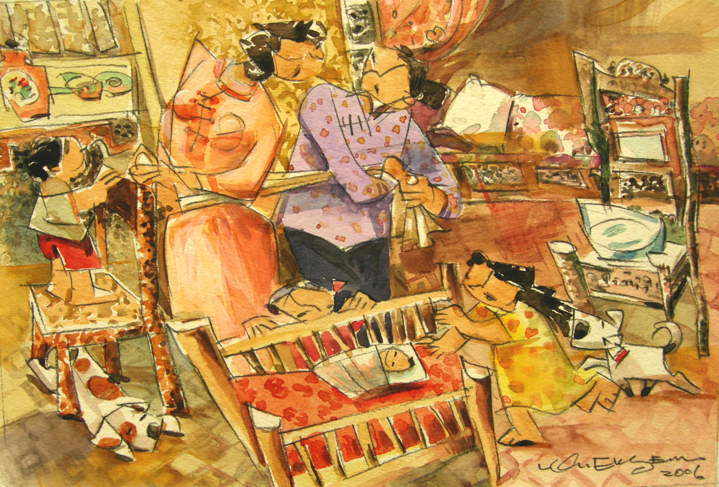
Special Treatment
Shortly after delivery, the midwife gives the mother special treatment to help her ‘push’ her stomach muscles back into shape. This involves tying a six metre cummerbund tightly around the mother’s stomach.

